**File Management:**

**Create, rename, or delete multiple files based on a pattern or criteria.**

**Organize files into a specific directory structure.**

**Back up or archive important files.**

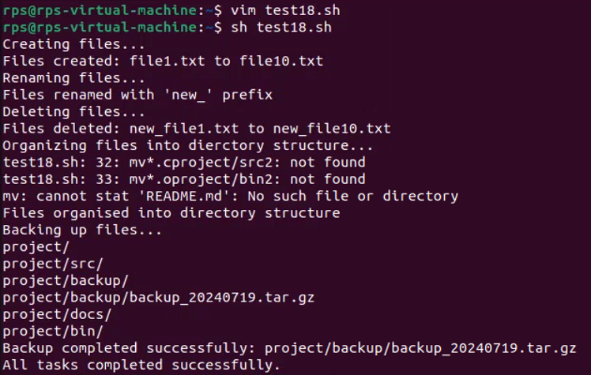

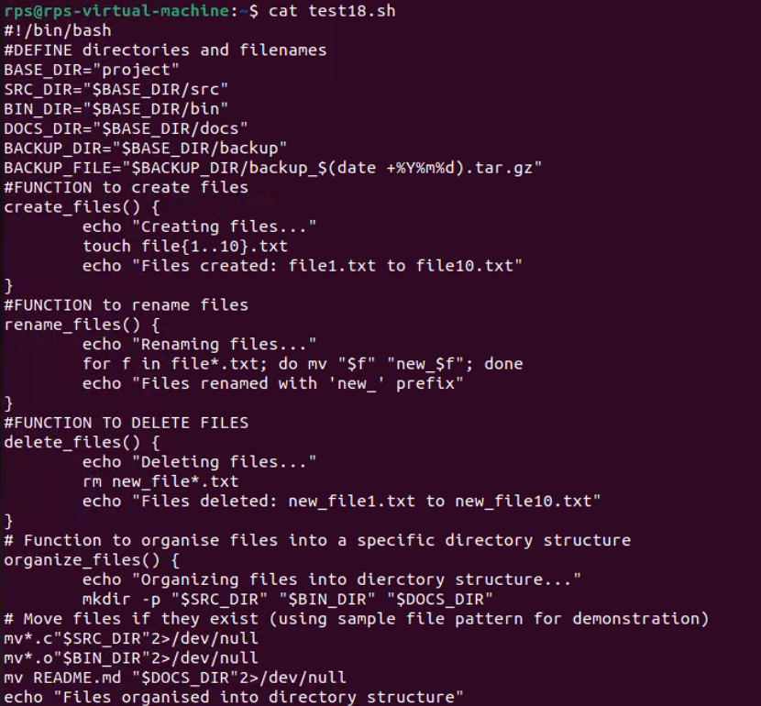

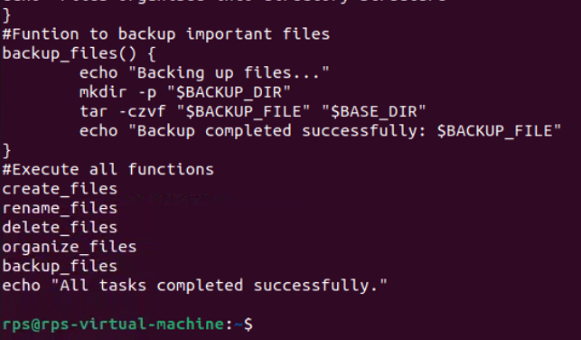

**Text Processing:**

**Search and replace text within a group of files.**

**Extract specific information from log files or data sets.**

**Format text files in a particular way**

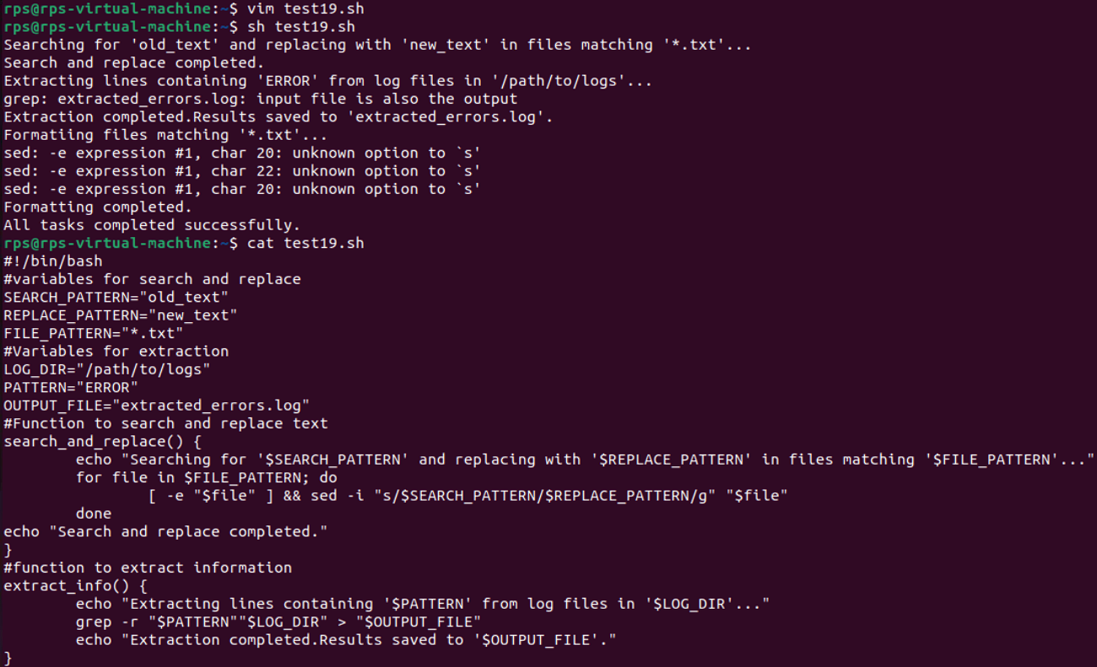

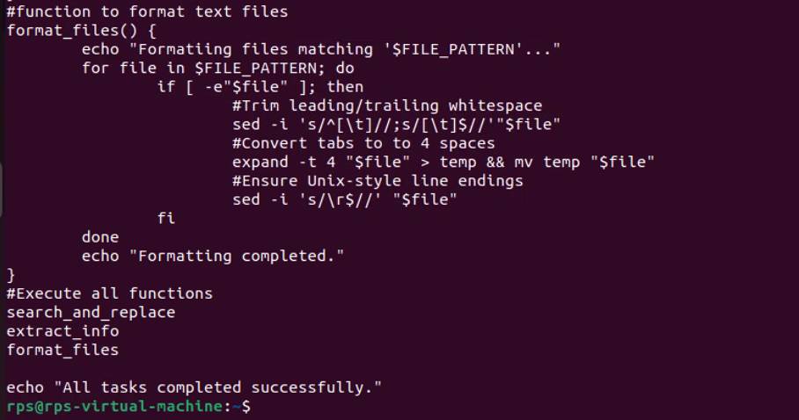

**Program:**

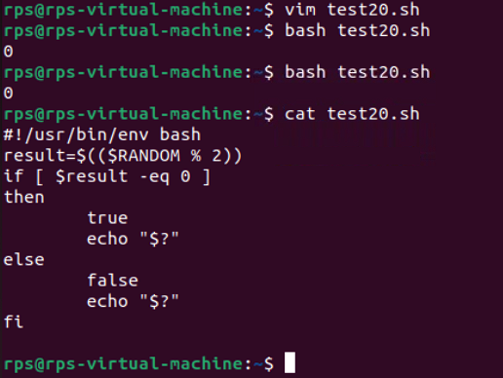

**Exercise 3: Write a shell script called file_checker.sh that check If a file exists or not. The script take in a file name as an argument and try to run cat on that file. The script should then check the exit code of the cat command to determine if the file exists or not. If the file exists, the script should print File exists!. If the file does not exist, the script should print File does not exist!.**

**Bonus: change the script to suppress the actual output of cat and only include your script's output (e.g. File exists! or File does not exist!).**

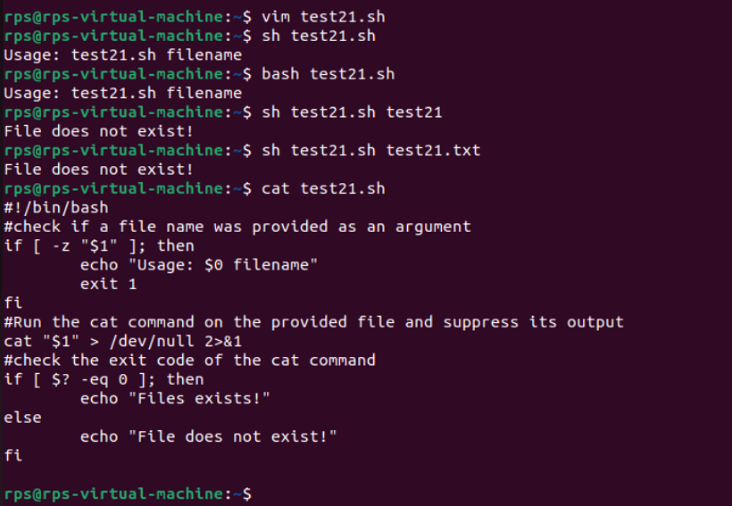

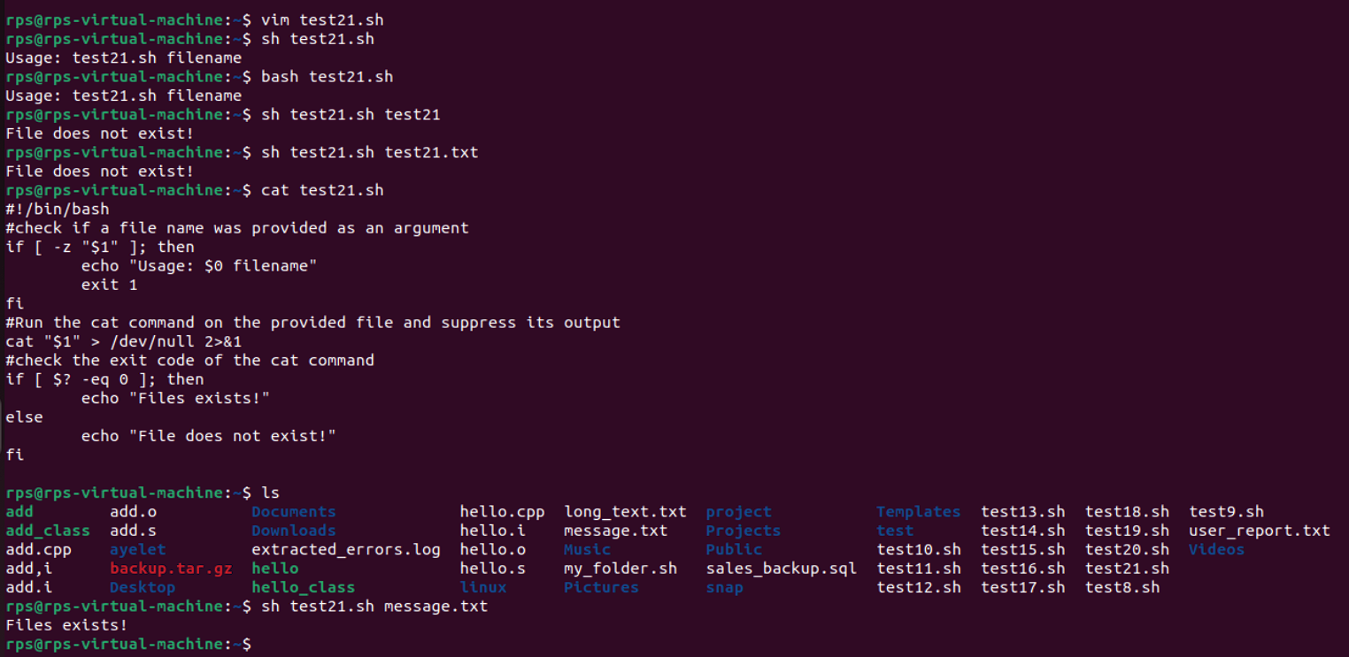

**$$ is the PID of the current process.**

**$? is the return code of the last executed command.**

**$# is the number of arguments in $\***

**$* is the list of arguments passed to the current process**

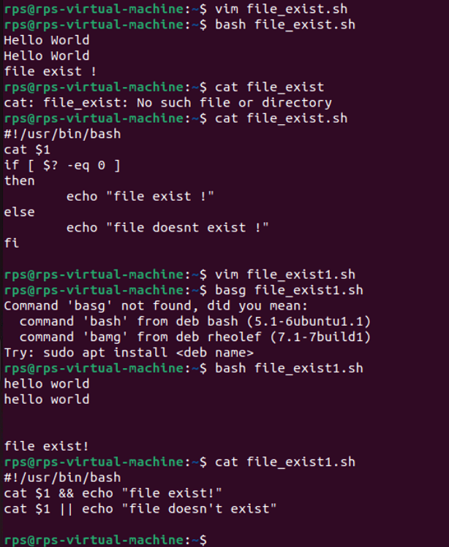

**Listall:**

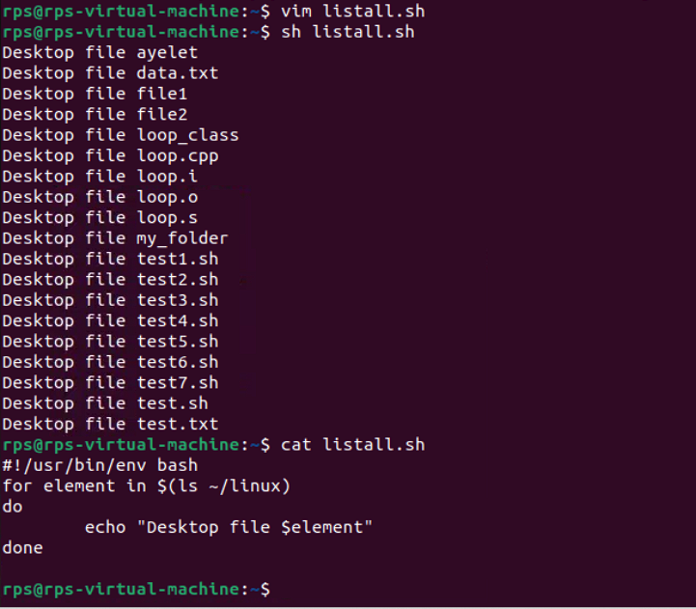

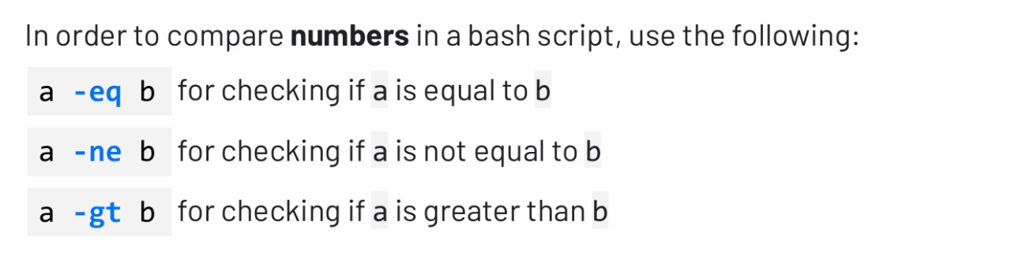

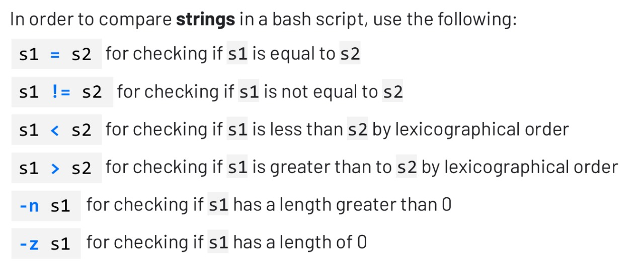

**Write a shell script called**

**timely_greeting**

**.sh that greets**

**you based on the current time. The script should call the**

**date**

**command, extract the current hour (look into using**

**%H) and then print**

**the following greeting based on the time.**

**If it is between 5AM (05:00) and 12PM (12:00):**

**Good morning!**

**If it is between 12PM (12:00) and 6PM (18:00):**

**Good afternoon!**

**If it is between 6PM (18:00) and 5AM (5:00):**

**Good night!**

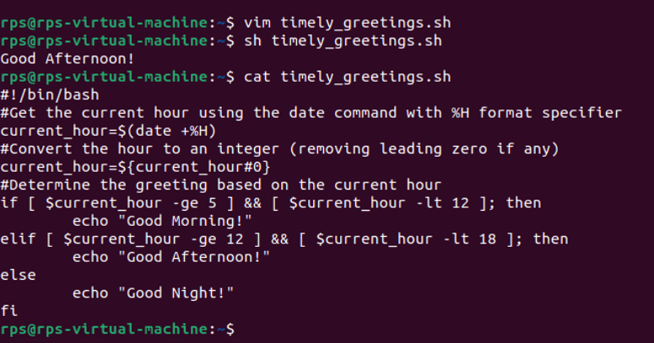

**Extend the script to include multiplication and division operations, and handle division by zero appropriately.**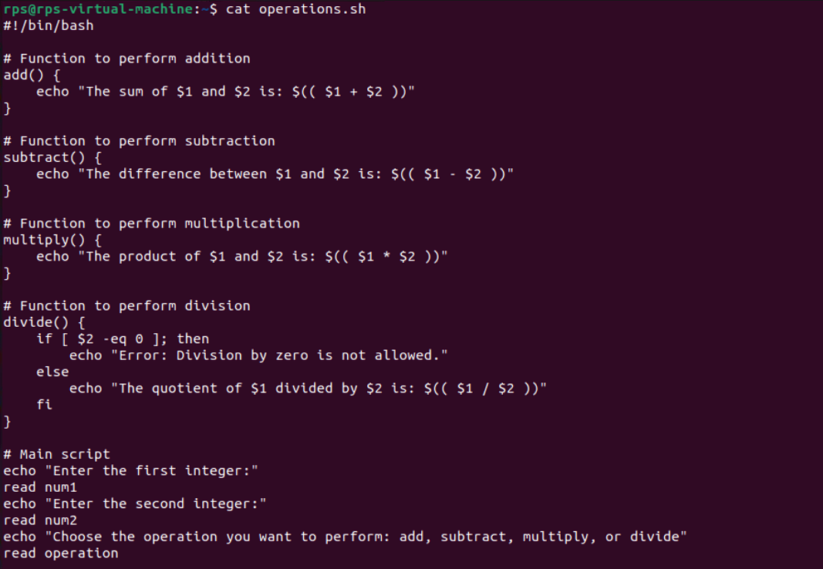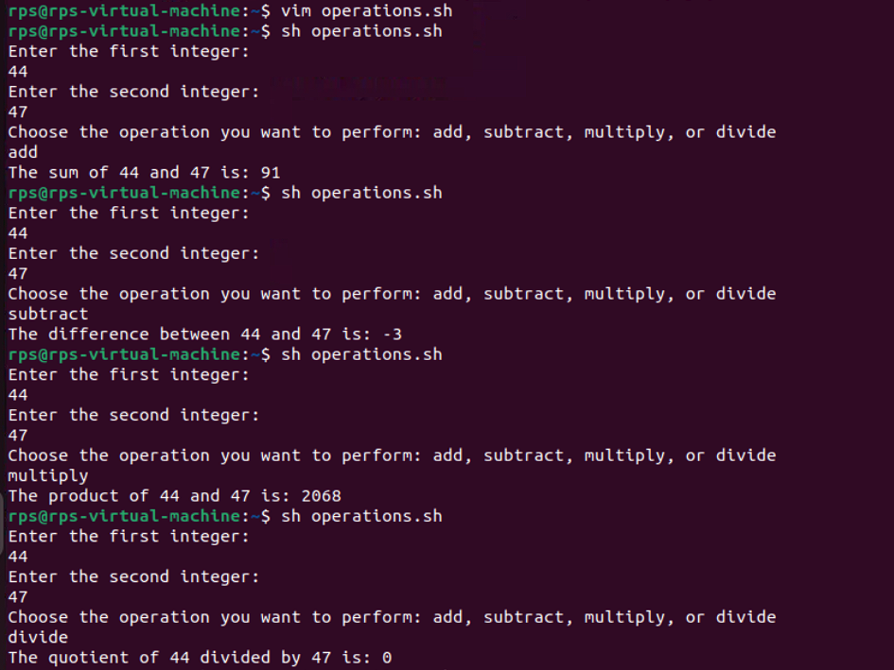

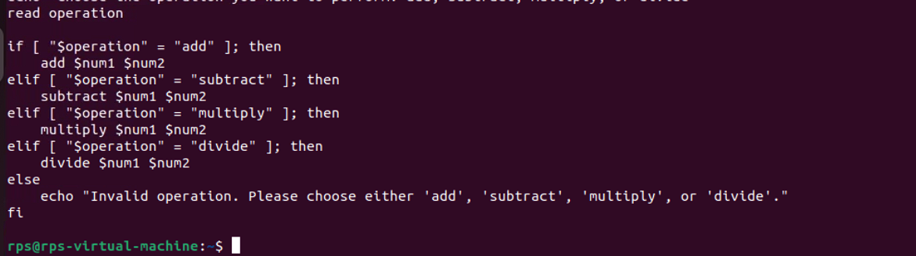

**Title: Create, Write, and Read Files Using Shell Script**

**Objective:**

**Develop a shell script that can create a file, write user-provided content into the file, and then read and display the content of the file.**

